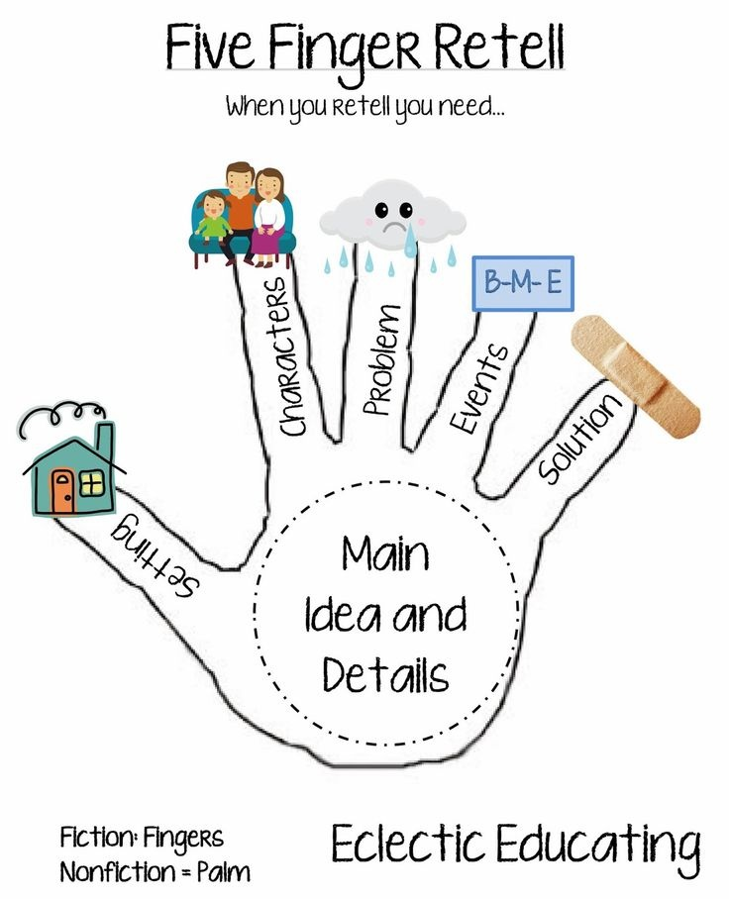
When retelling STORIES, use your hand (starting with the thumb and moving to the index finger) to restate the story elements.
When retelling NONFICTION use the opposite hand. Use the palm to state the main idea and the five fingers for the important facts, or details, that relate to the main idea.

